Rotary Club of Kathmandu Mid-Town
Breakfast Chatter




18 November 2011 The Weekly Bulletin of Rotary Club of Kathmandu Mid-Town Bc-11.18/011-12

District: 3292 Web: www.rotarymidtown.org.np Club Id : 26776

NOVEMBER IS THE ROTARY FOUNDATION MONTH
Participation in Foundation programs is an important part of the Foundation’s success. To allow districts a voice in how contributions are spent and the fullest possible participation, the Trustees developed the share system for the allocation of funds. Through the system:
- Rotarians share their resources with their fellow Rotarians around the world.
- The Trustees share some of their decision-making responsibility with the districts.
- Rotarians share Rotary with the world through their Foundation.

Friday, 11 November:

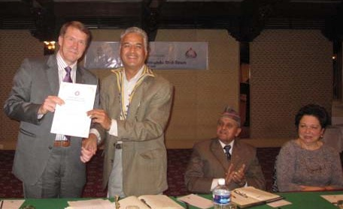
Guest speaker Passi Koistinen, CEO, NCell,
receiving certificate of appreciation from President Som

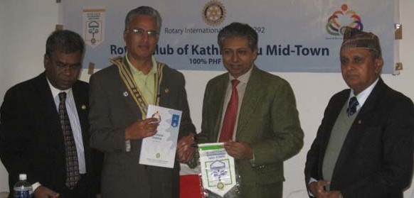
President Som exchanging club
Flags with RC Dhaka Central
Visitors Rtn Hussain and
Rtn Siddique

Weekly Meetings and Programs :
Date | Program/Speaker | Program/Topics of Presentation
18 November 2011 | Charter Nite | Charter Nite
25 November 2011 | 2nd Club Assembly | 2nd Club Assembly
2 December 2011 | Dr Donald Sammut | Plastic/ Hand Surgery Experiences
9 December 2011

18 November, Friday:
Charter Nite

Friday, 18 November 2011
At Dhaba Restaurant, Thapathali
Time: 5.30 PM starting
Park your car at Shikhar Insurance Lane, across the Road
The cost for the spouses/guests will be only Rs 1000

Computer handover:
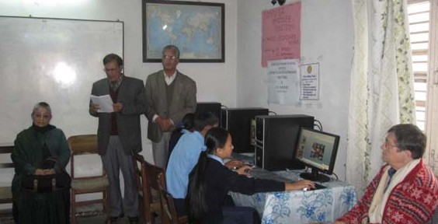
Three computer sets and 3 UPS were handed over to Nandi Secondary School, Nagpokhari, Naxal
under RC Kathmandu MidTown and RC Borken collaboration on Sunday 13 Nov 2011.
In photo, Headmaster Bhola Thapaliya, President Dr Som Pudasaini, PP Ambica and Rtn Jo.

Walk for Disability Awareness on Saturday, 3 Dec 2011:
The Nepal Orthopaedic Hospital is organizing a ‘walk for disability awareness’ program on Saturday,
3 Dec 011 morning to coincide with the 20th International Day of Disabled Persons.
The objective of the program is to raise awareness about disability and also to raise some funds that will go for treating poor patients coming to the hospital.
The event will start at 7:00 AM from Basantapur Durbarsquare to around Kathmandu via Ason, Durbarmarg, Bhadrakali, Newroad gate and back to Basanatapur.
Participants will each get one T-shirt with appropriate logos and also breakfast.
The program is considered as a District event. Participation is by purchasing ticket costing Rs 1,000 per person or by donating fund for the event.

Stewardship of The Rotary Foundation Funds:
The Trustees recognize that the funds received from Rotarians and other supporters around the world are voluntary contributions reflecting their hard work and dedicated support. These donors have entrusted The Rotary Foundation with the faith and understanding that their contributions will be used effectively and for the purposes for which they were given. Therefore, the Trustees, acting in their capacity as stewards of these funds, stress the importance of proper fiscal management in any activity associated with the programs of The Rotary Foundation. The Trustees rely on the integrity of the districts, the clubs, and the Rotarians engaged in project implementation to ensure that funds are used effectively for the purposes for which they were given. The Trustees will promptly investigate any irregularities coming to their attention and take whatever action may be appropriate.
The recipient of a grant, the grant’s sponsors, and all others associated with the project are expected to:
1) Treat Rotary Foundation funds as a sacred trust to be constantly safeguarded from loss, misuse, or diversion and to be used only for the stated purpose, which shall be strictly interpreted;
2) Exercise the highest attention to preventing even the appearance that Rotary Foundation funds are being used improperly, whether such appearance may be in the eyes of Rotarians or the general public. Such attention is expected to go beyond that afforded to the use of private or corporate funds;
3) Ensure competent and thorough oversight of the project with clear delineation of responsibility;
4) Conduct all financial transactions and project activity relating to the grant at least at the level of standard business practice and always in harmony with the Declaration of Rotarians in Businesses and Professions and in the full spirit of The Four-Way Test;
5) Report immediately any irregularity in grant-related activity to The Rotary Foundation;
6) Implement projects as approved by the Trustees in their grant award. Any deviation from the agreed terms or changes in the implementation of the project must receive prior written authorization from The Rotary Foundation;
7) Arrange for independent financial and performance reviews or audits in accordance with current Trustee policy and guidelines;
8) Make timely and detailed reports on both program and financial activities;
9) Be held accountable for appropriately addressing all concerns regarding project implementation for which notification has been sent;
10) Demonstrate transparency in business transactions related to Rotary Foundation program grants and awards by operating in a manner that avoids any actual or perceived conflict of interest.

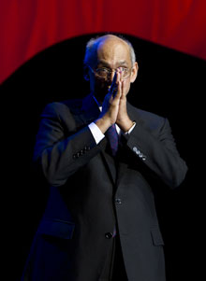
In Rotary, we are all aware of the great needs in so many parts of our world. And we all
know how much we can do to help through our Rotary Foundation. We can change lives,
we can restore hope, we can build futures – if we choose to.
RI President Kalyan Banerjee

On Lighter Side : Click here ⇩


Please send project/activity information, suggestions and photos etc to :
BC Editor: RR Shrestha email: rryes@wlink.com.np

18 November 2011 The Weekly Bulletin of Rotary Club of Kathmandu Mid-Town bc-11.18/011-12

